# Logo Change – To round Logo – Get from Zahid

# Remove this

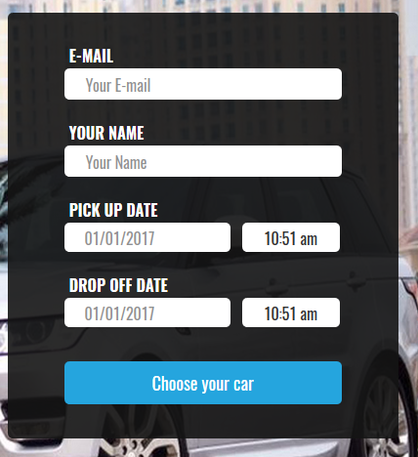

# About Us

Background

Established in the year 2014 Salik Auto is a 100% Qatari based car rental and limousine service company that offers a wide range of deluxe cars available around the clock, with quality services and competitive prices, where Salik draws strategic plans with the insistence to rise to the top and achieve our future mission.

Salik is drastically diversifying to suit the current market requirements and moving onto its new areas of spare parts and breakdown services whilst maintaining the requirements and keeping up with the new and latest technologies in the region.

# Our Mission

Is of becoming the number one Qatari company in the presence of honesty, credibility and devotion

# Our vision

That Salik becomes one of the best for transportation ins the state of Qatar to achieve and assist Qatar vision 2030 that aims to make Qatar a developed country capable of achieving the sustainable development and to ensure the continuation of decent living to its nation generation after generation.

# Our team

Ahmad M. Al Hamadi – CEO and Co – Founder

Abdul Aziz M. Al Horr – Co -Founder

Hassan M. Al Hamadi – Operations Manager

Ahmad Ragab – Group Manager

# Our services

1. Limousine and pick up services – Get yourself picked from your step – Hotline and Salik App Details

Contact Salik Limousine – 77000977 / Toll Free - 8000005

1. Rent a Car services – Rent a Car over your phone and get it delivered to your door step now!

Display The cars available for renting – Zahid   
Contact details of rent car sales reps - Zahid

1. Breakdown services – Anywhere at Any time! Call us on 8000005
2. Spare Parts services – Coming Soon

# New Tab - Promotions & Special

**Elite club – Special rates for loyal customers**

The club established by Salik to its loyal customers to ensure high standards of service and better benefits through the scheme of discounts to 3 level of loyalty

* Silver Membership (10% Discounts)
* Gold membership (15% Discounts)
* Platinum membership (25% Discounts)

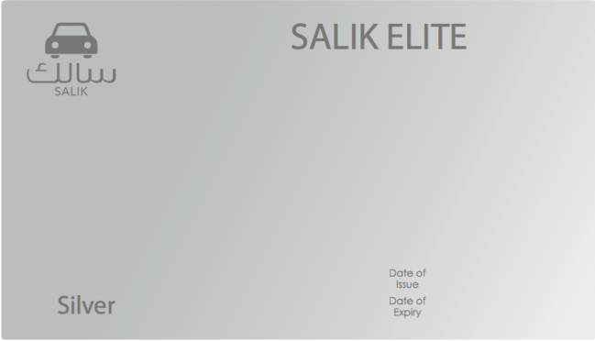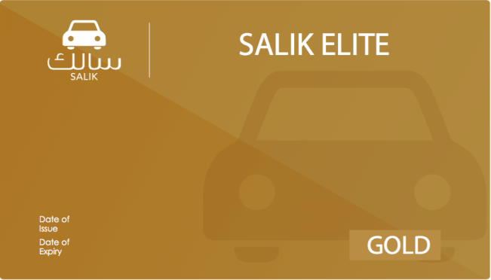

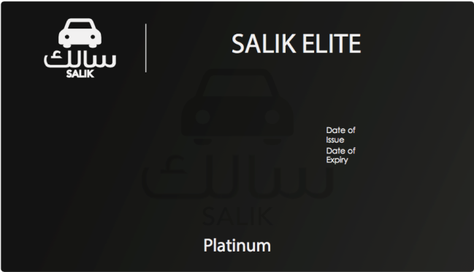

**Transporting needs for the disabled and those with special needs.**

# New Tab – Gallery

Include the images of the cars – Zahid

# New Tab - Partners

Masraf Al Rayan - Exclusive deal with Masraf Al Rayan to provide special discounts and rebates to all of the banks card holders

Salik and Careem - Exclusive deal with Careem to operate the only VIP limousine fleet in Qatar

# Contact us

Include all 3 branch locations – Zahid

Contact numbers of each branch   
**AL AZIZIA** -**77 000 977  
AL SADD - 30 000 729  
PEARL - 33 081 111**

Include Social Media Links - Zahid